**ER diagram of Branch user views of *DreamHome (Fig. 12.1)***

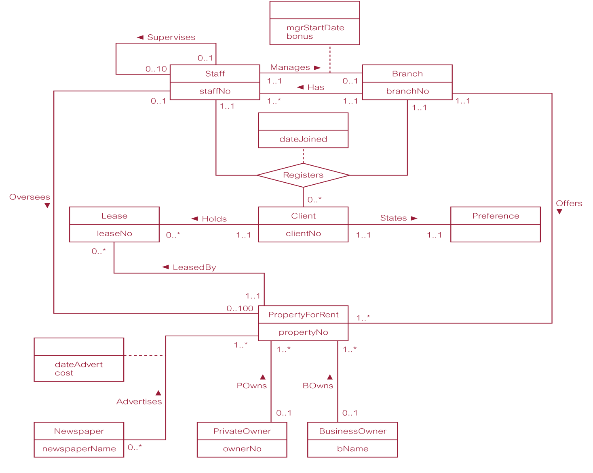

***ER diagram of Branch Has Staff relationship***

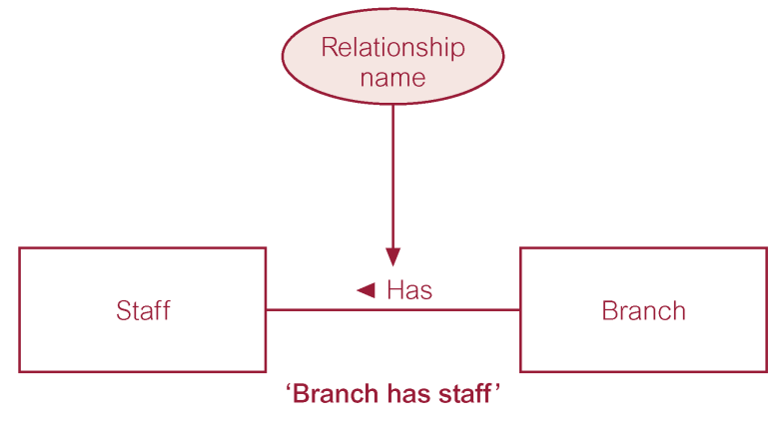

***Binary relationship called POwns***

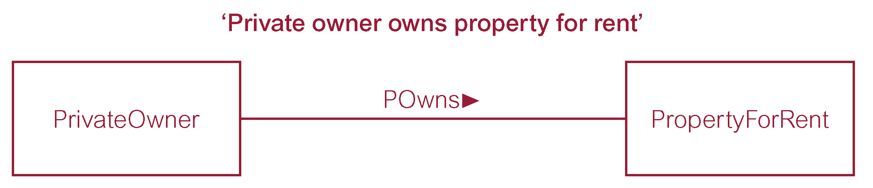

***Ternary relationship called Registers***

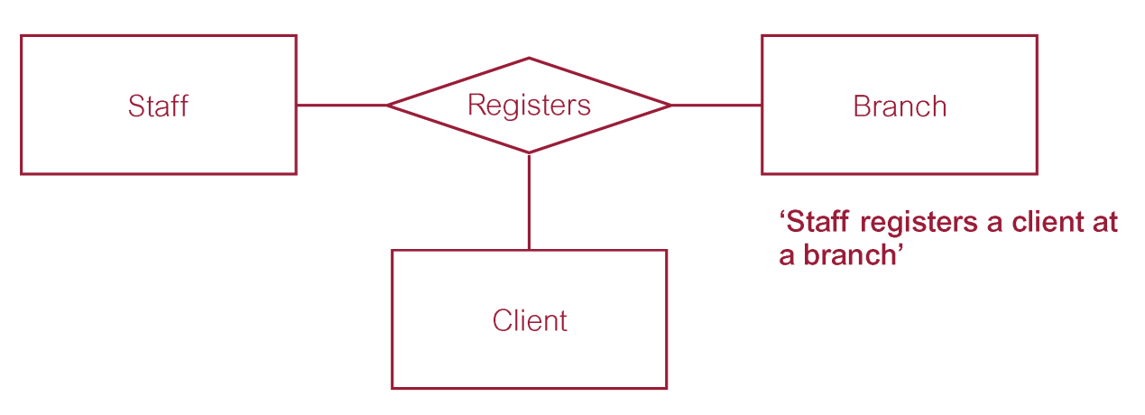

***Quaternary relationship called Arranges***

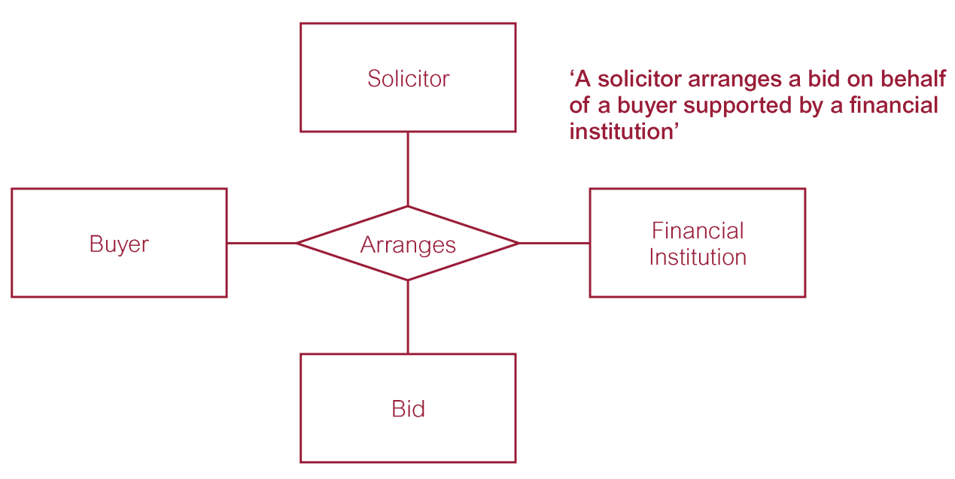

**Recursive relationship called *Supervises* with role names**

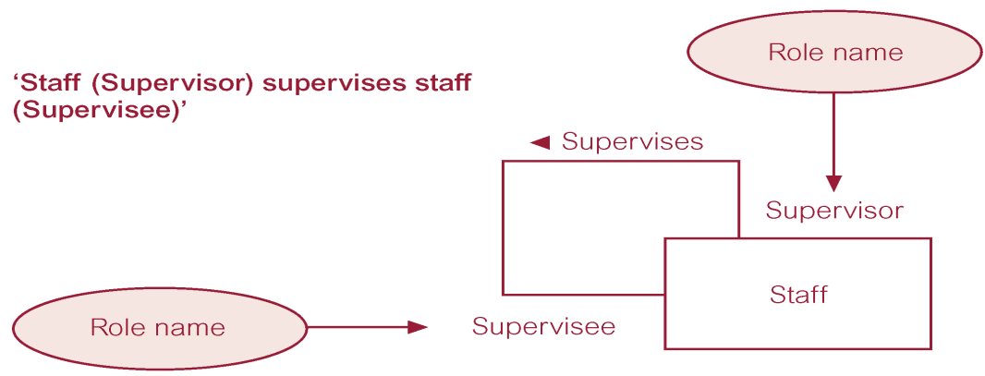

**Entities associated through two distinct relationships with role names**

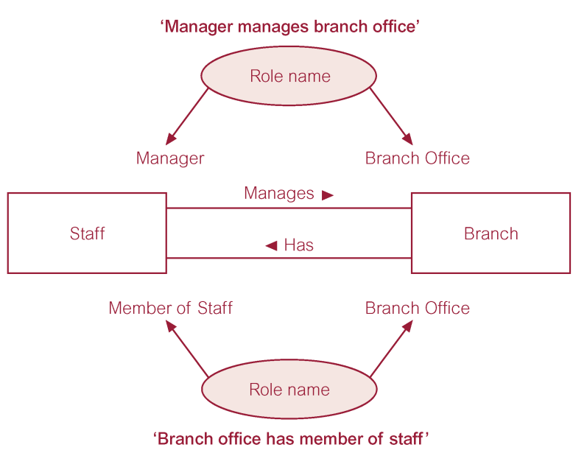

**ER diagram of Staff and Branch entities and their attributes** 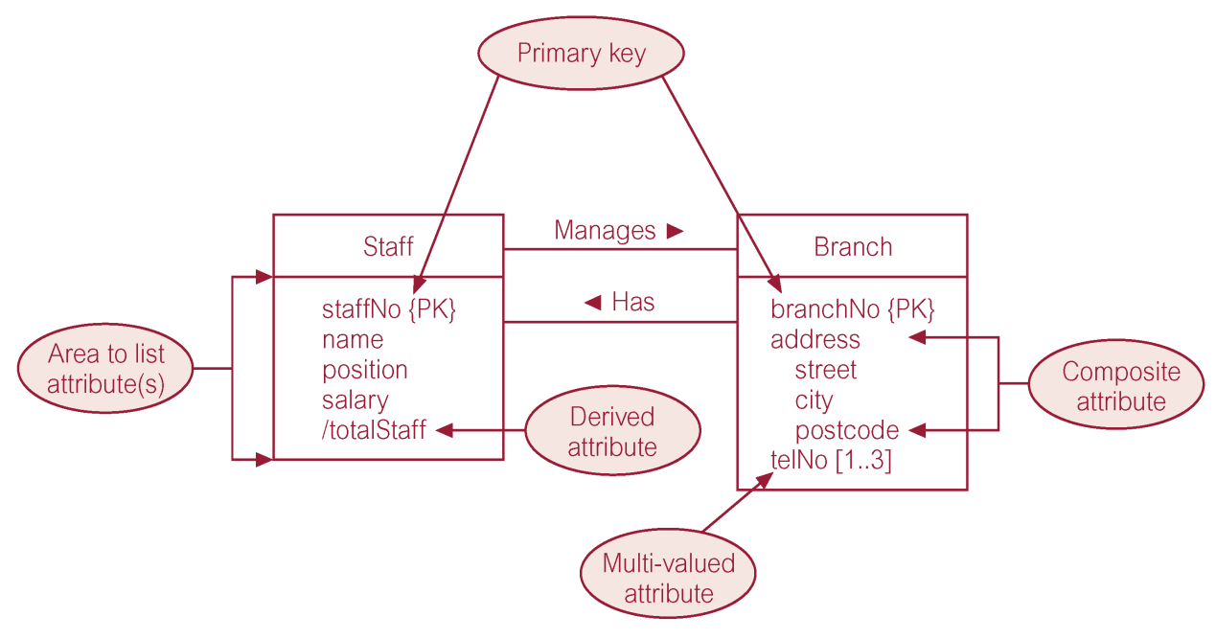

**Strong entity type called Client and weak entity type called Preference**

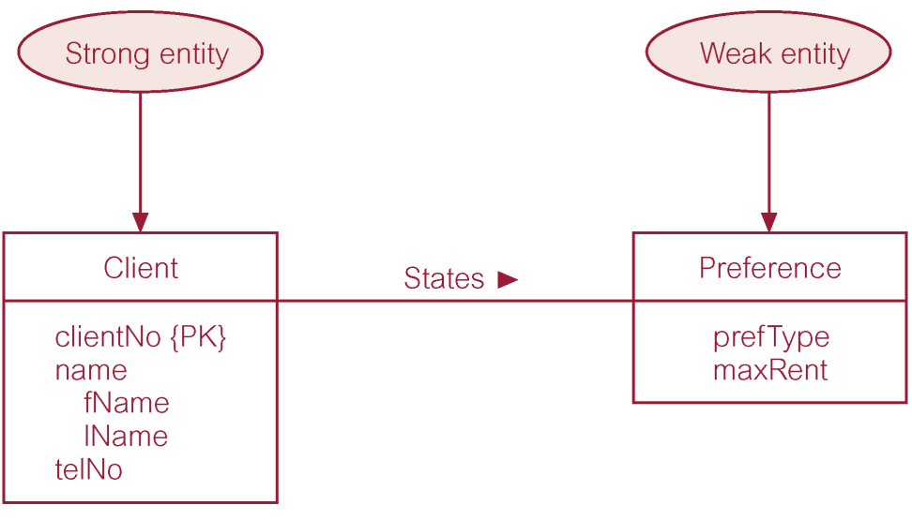

**Attributes on Relationships**

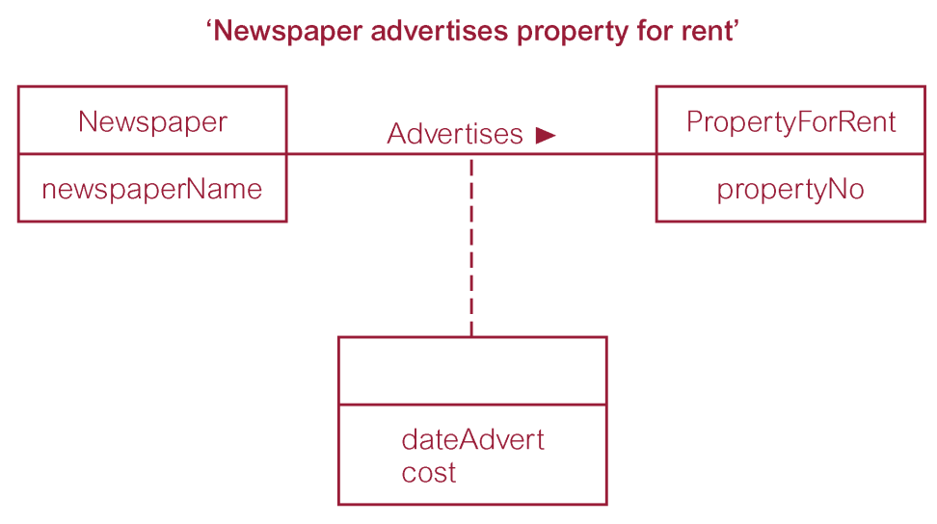

**ER diagram showing the multiplicity of the Staff *Manages* Branch one-to-one (1:1) relationship.**

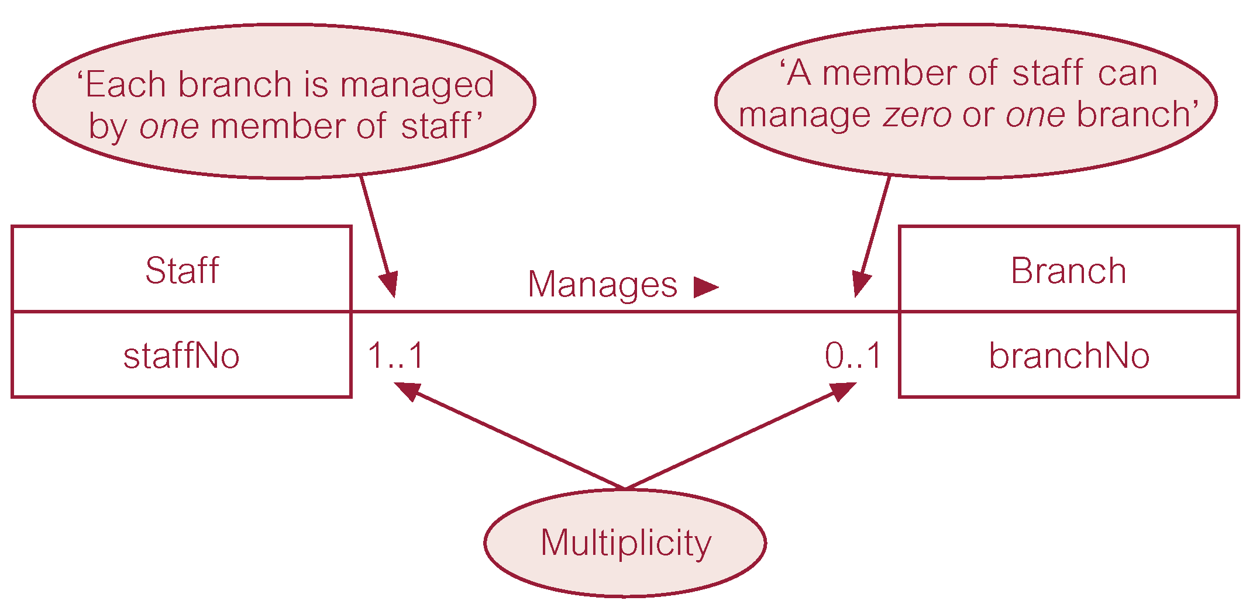

**ER diagram showing the multiplicity of the Staff *Oversees* PropertyForRent one-to-many (1:*) relationship.**

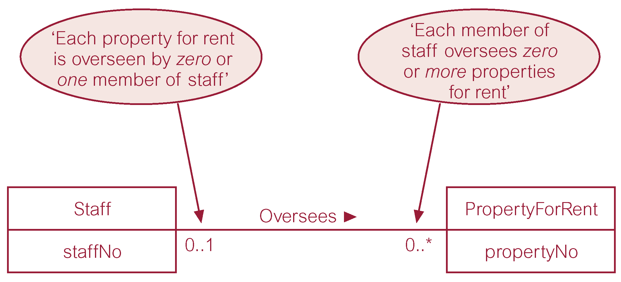

**ER diagram showing the multiplicity of the Newspaper *Advertises* PropertyForRent many-to-many (*:*) relationship.**

